HTML CODES

1)About
<html lang="en">
<head>
<meta charset="UTF-8">
<title>About Page</title>
<style>
body{
font-family:Arial,sans-serif;
margin:40px;
}
</style>
</head>
<body>
<h1>About Us<h1>
<p>This is the About page.We are learning Html lnks!
</p>
<p><a href="index.html">Back to home<a></p>
</body>
</html>

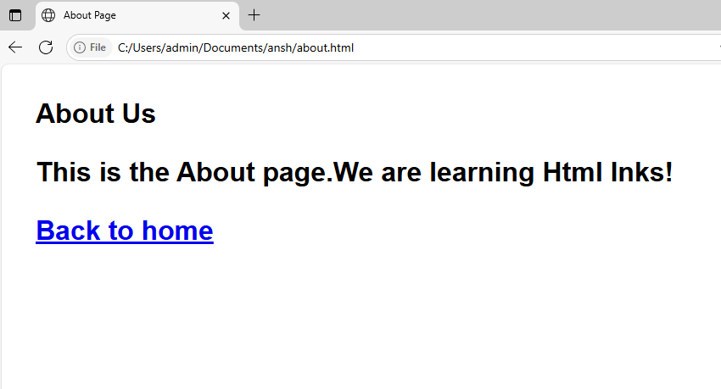

2)Extintlink
<html lang="en">
<head>
<meta charset="UTF-8">
<title>Links Example</title>
<style>
body{
font-family:Arial,sans-serif;
margin:40px;
line-height:1.6;
}
a{
color:#3366cc;
text-decoration:none;
}
a:hover{
text-decoration:underline;
}
section{
margin-top:50px;
}
</style>
</head>
<body>
<h1>Types of links in html</h1>

<h2>External Links</h2>
<p>
Visit
<a href="https://www.wikipedia.org" target="_blank">Wikipedia</a>for more information.
</p>
<h2>Internal Link</h2>
<p>
Go to the
<a href="about.html">About Page</a>.
</p>
<p style="color:gray;font-size:14px;">
(Note:Create a separate file named<code>about.html</code>in the same folder for this link to work.)
</p>
<h2>Link Within Same Page</h2>
<p>
Jump to the
<a href="#bottom">bottom of this page</a>.
</p>
<section style="height:400px;">
<p>Scroll down to see the anchor target below.</p>
</section>
<h3 id="bottom">Bottom of the page</h3>
<p>This is the target for the same-page link.</p>

</body>
</html>
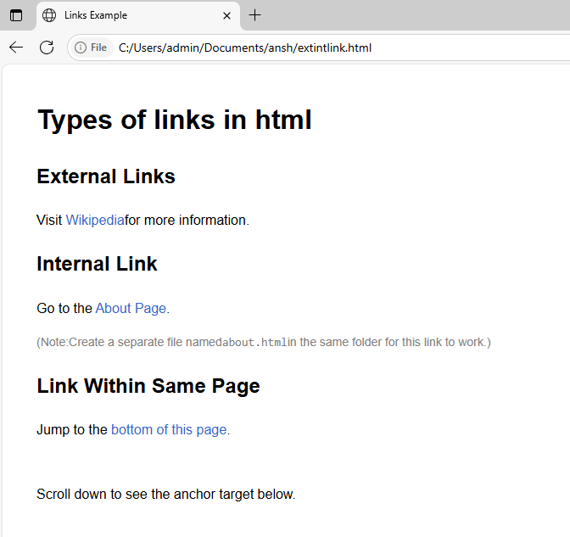

3)order
<html lang="en">
<head >
<meta charset="UTF-8">
<title>Types of Lists in HTML
</title>
<style>
body{
font-family:Arial,sans-serif;
margin: 40px;
}
</style>
</head>
<body>
<h2>Ordered List</h2>
<ol>
<li>Apple</li>
<li>Banana</li>
<li>Cherry</li>
</ol>

<h2>Unordered List</h2>
<ul>
<li>Red</li>
<li>Green</li>
<li>Blue</li>
</ul>

<h2>Description List</h2>
<dl>
<dt>HTML</dt>
<dd>A markup language for creating web pages.</dd>

<dt>CSS</dt>
<dd>A style sheet language for designing web pages.</dd>

<dt>JavaScript</dt>
<dd>A programming language for adding interactivity to web pages.</dd>
</dl>
</body>
</html>
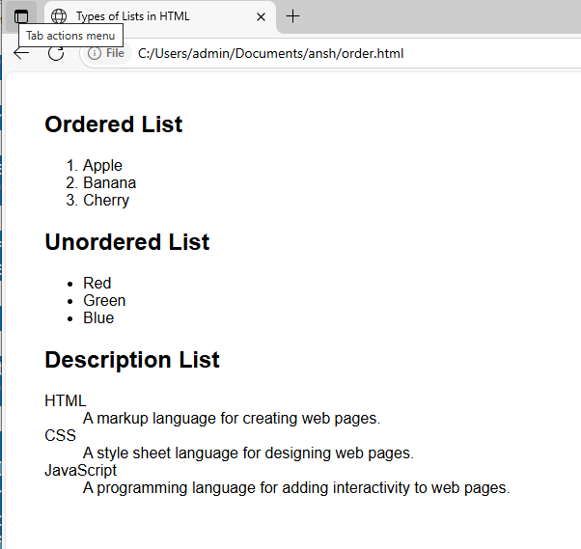

4)Table
<html lang="en">
<head>
<meta charset="UTF-8">
<title>Student marks table</title>
<style>
body{
font-family:Arial,sans-serif;
margin:40px;
}
table
{
border-collapse:collapse;
width:70%;
}
th,td{
border:1px solid #333;
padding:10px;
text-align:left;
}
th{
background-color:#f2f2f2;
}
caption{
caption-side:top;
margin-bottom:10px;
font-size:18px;
font-weight:bold;
text-align:left;
}
.average-row td{
background-color:#e6f7ff;
font-weight:bold;
text-align:left;
}
</style>
</head>
<body>
<table>
<caption>Students Marks Table</caption>
<tr>
<th>Name</th>
<th>Subject</th>
<th>Marks</th>
</tr>
<!--Rajshree-->
<tr>
<td rowspan="2">Rajashree</td>
<td>Adv Web</td>
<td>75</td>
</tr>
<tr>
<td>OS</td>
<td>60</td>
</tr>
<!--Kiran-->
<tr>
<td rowspan="2">Kiran</td>
<td>Adv Web</td>
<td>80</td>
</tr>
<tr>
<td>OS</td>
<td>75</td>
</tr>

<!--Average Row-->
<tr class="average-row">
<td></td>
<td colspan="2">Average of all marks:72.5</td>
</tr>
</table>
</body>
</html>
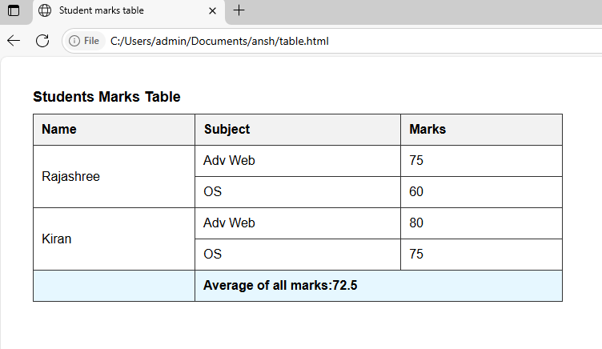

6)Form
<!DOCTYPE html>
<head>
<title>Form in HTML</title>
</head>
<body>

<h2> Registration Form</h2>
<form>
<fieldset>
<legend>User Personal Information</legend>
<label>Enter your full name</label><br>
<input type="text" name="name"><br>
<label>Enter your email</label><br>
<input type="email" name="email"><br>
<label>Enter your password</label><br>
<input type="password" name="pass"><br>
<label>Confirm your password</label><br>
<input type="password" name="pass"><br>
<br><label>Enter your gender</label><br>
<input type="radio" id="gender" name="gender" value="male">Male<br>
<input type="radio" id="gender" name="gender" value="female">Female<br>
<input type="radio" id="gender" name="gender" value="others">others<br>
<br>Enter your Address:<br>
<textarea></textarea><br>
<input type="submit" value="sign-up">
</fieldset>
</form>

</body>
</html>
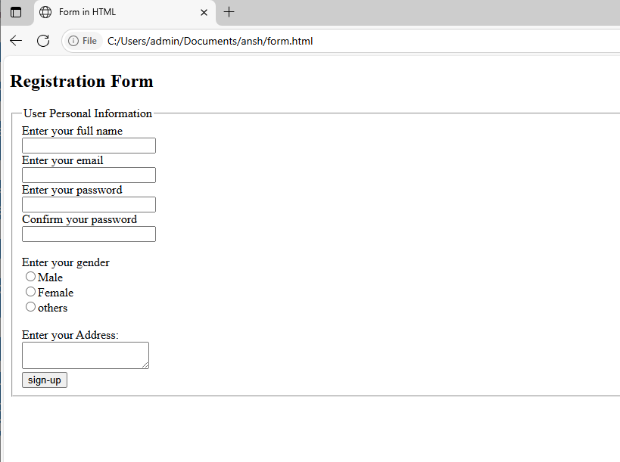

12)Tablemerge
<!DOCTYPE html>
<html lang="en">
<head>
<meta charset="UTF-8"/>
<meta name="veiwport" content="width=device-width,initial-scale=1"/>
<title>3x3 Table with rowspan and colspan</title>
<style>
table{
border-collapse:seperate;
border:2px solid black;
cellspacing:5px;
cellpadding:10px;
}
td{
border:1px solid#000;
padding:10px;
text-align:center;
}
</style>
</head>
<body>
<h2>3x3 Table Example with cellspacing,cellpadding,rowspan,colspan</h2>
<table border="1" cellspacing="5" cellpadding="10">
<tr>
<td rowspan="2">Row 1 & Row 2<br>Col 1</td>
<td>Row 1 <br>Col 2</td>
<td>Row 1 <br>Col 3</td>
</tr>
<tr>
<!--first cell is rowspan,so skipped-->
<td colspan="2">Row 2<br>Col 2 & 3 merged</td>
</tr>
<tr>
<td>Row 3<br>Col 1</td>
<td>Row 3<br>Col 2</td>
<td>Row 3<br>Col 3</td>
</tr>
</table>
</body>
</html>
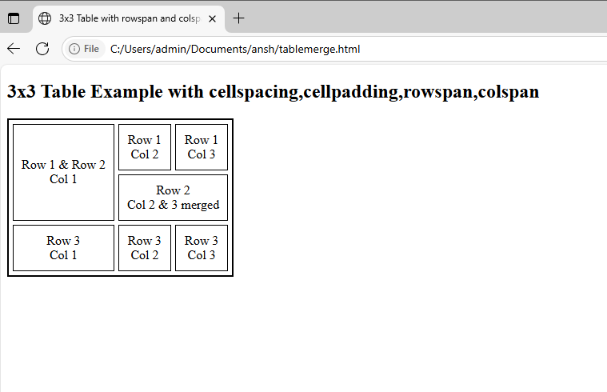
18)List
<!DOCTYPE html>
<html lang="en"
<head>
<meta charset="UTF-8"/>
<meta name="veiwport" content="width=device-width,initial-scale=1">
<title>Nested List With Colors</title>
<style>
ol{
color:green;
font-weight:bold;
}
ol li ul{
color:red;
list-style-type:disc;
font-weight:normal;
}
ol li ul li{
color:red;
}
</style>
</head>
<body>
<h2>Nested list Example</h2>
<ol>
<li>Fruits
<ul>
<li>Apple</li>
<li>Banana</li>
<li>Orange</li>
</ul>
</li>
<li>Vegetables
<ul>
<li>Carrot</li>
<li>Broccoli</li>
<li>Spinach</li>
</ul>
</li>
<li>Grains
<ul>
<li>Rice</li>
<li>Wheat</li>
</li>Barley</li>
</ul>
</li>
</ol>
</body>
</html>
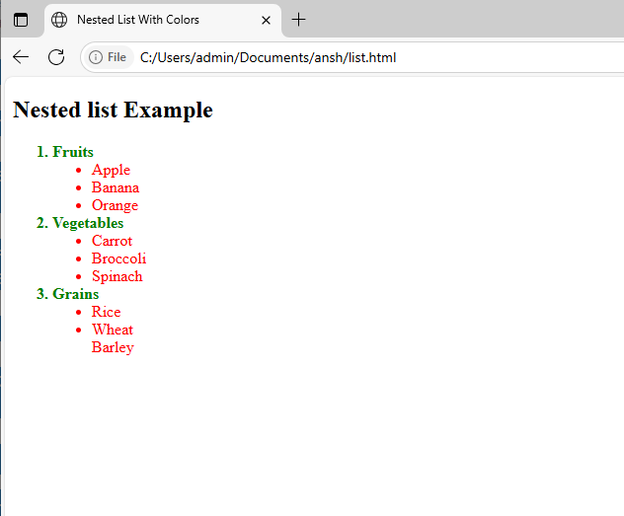

13)Hyperlink
<!DOCTYPE html>
<html lang="en">
<head>
<meta charset="UTF-8"/>
<meta name="viewport"content="width=device-width,initial-scale=1"/>
<title>Hyperlink Example</title>
</head>
<body>
<h2>Hyperlink Examples</h2>
<!--i)Text as hyperlink-->
<p>
Click this <a href="https://www.example.com" target="_blank">text hyperlink</a>to go to Example.com.
</p>

<!--ii)Image as hyperlink-->
<p>
<a href="https://www.example.com"target="_blank">
<img src="https://via.placeholder.com/150"alt="Placeholder Image" style="border:1px solid#000;"/>
</a>
</p>

<!--iii)Hyperlink to yahoo.com-->
<p>
Go to<a href="https://www.yahoo.com" target="_blank">Yahoo</a>
</p>
</body>
</html>
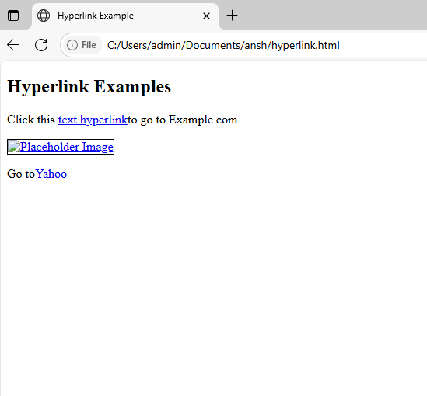
8)Login page
<!DOCTYPE html>
<html lang="en">
<head>
<title>Pure CSS Login Form</title>
<meta charset="UTF-8"/>
<meta name="viewport" content="width=device-width"/>
<link rel="stylesheet" href="styles.css"/>
</head>
<body>
<div class="container">
<div class="center">
<h1>Login</h1>
<form action="" method="POST">
<div class="txt_field">
<input type="text" name="text" required>
<span></span>
<label>Username</label>
</div>
<div class="txt_field">
<input type="password" name="password" required>
<span></span>
<label>Password</label>
</div>
<div class="pass">Forget Password?</div>
<input name="submit" type="button" value="Submit">
<div class="signup_link">
Not a member?<a href="signup.php">Signup</a>
</div>
</form>
</div>
</div>
</body>
</html>
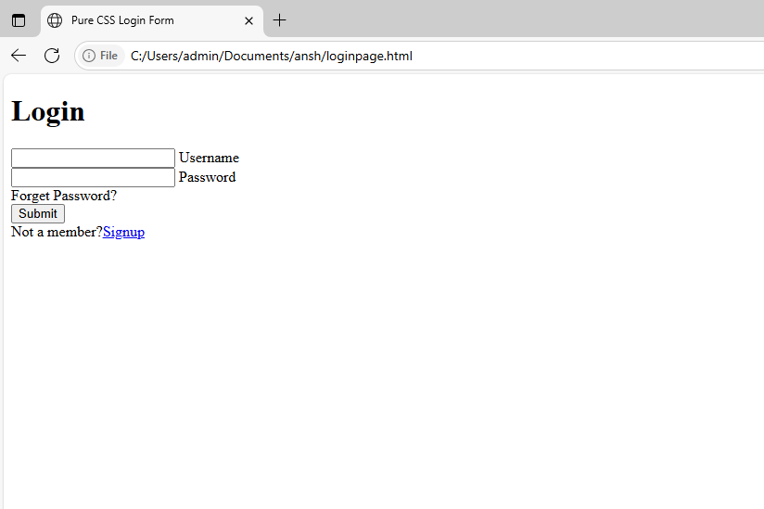
23)Invitation
<!DOCTYPE html>
<html>
<head>
<title>Birthday Invitation</title>
<style>
body{
background-color:#ffe6f0;
font-family:'Segoe UI',Tahoma,Geneva,Verdana,sans-serif;
text-align:center;
margin:0;
padding:0;
}
.card{
backkground-color:#fffOf5;
width:60px%;
margin:50px auto;
padding:30px;
border-radius:15px;
box-shadow:0 4px 8px rgba(0,0,0,0.2);
}
h1{
color:#d63384;
font-size:36px;
margin-bottom:10px;
}
h2{
color:#6f42c1;
font-size:24px;
}
p{
color:#333;
font-size:18px;
margin:10px 0;
}

.footer{
margin-top:30px;
font-style:italic;
color:#6c757d;
}
</style>
</head>
<body>
<div class="card">
<h1>You're Invited!</h1>
<h2>To My Birthday Party🎉</h2>
<p><strong>Date:</strong>Saturday,August 10th,2025</p>
<p><strong>Time:</strong>4:00PM -8:00PM</p>
<p><strong>Venue:</strong>123 Party Lane,Happy Town</p>
<p>There will be music,games,food,and lots of fun!</p>
<p>Come celebrate and make memories with me!🎂🎈</p>
<div class="footer">
Please RSVP by August 5th<br>
Contact:(123)456-7890 or email@example.com
</div>
</div>
</body>
</html>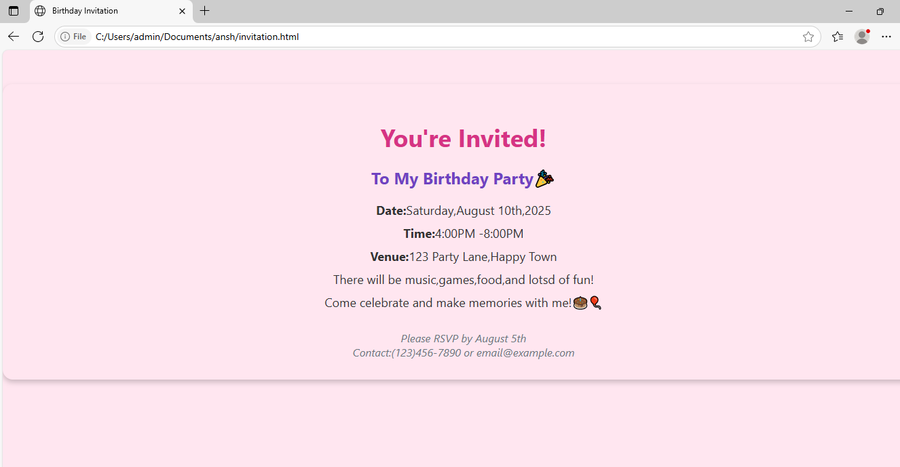

15)External css (make an separate folder)
i)index.html
<!DOCTYPE html>
<html lang="en">
<head>
<meta charset="UTF-8">
<title>Types of Lists in HTML</title>
<link rel="stylesheet" href="style.css">
</head>
<body>
<h1>HTML List Example</h1>

<section>
<h2>Unordered List</h2>
<ul>
<li>Apples</li>
<li>Oranges</li>
<li>Bananas</li>
</ul>
</section>
<section>
<h2>Ordered List</h2>
<ol>
<li>Wake up</li>
<li>Brush Teeth</li>
<li>Have Breakfast</li>
</ol>
</section>

<section>
<h2>Descriptiton List</h2>
<dl>
<dt>HTML</dt>
<dd>A markup language for web pages.</dd>
<dt>CSS</dt>
<dd>A language to style HTML content.</dd>
<dt>Javascript</dt>
<dd>A language to add interactivity to websites.</dd>
</dl>
</section>

<section>
<h2>Nested Lists</h2>
<ul>
<li>Fruits
<ul>
<li>Apple</li>
<li>Banana</li>
</ul>
</li>
<li>Vegtables
<ul>
<li>Carrot</li>
<li>Spinach</li>
</ul>
</li>
</ul>
</section>
</body>
</html>

ii)style.css
body{
font-family:Arial,sans-serif;
margin:20px;
line-height:1.6;
}

h1{
color:#333;
}

section{
margin-bottom:30px;
padding:10px;
border:1px solid#ddd;
border-radius:6px;
}

ul,ol,dl{
margin-left:20px;
}
dt{
font-weight:bold;
}
dd{
margin-left:20px;
margin-bottom:10px;
}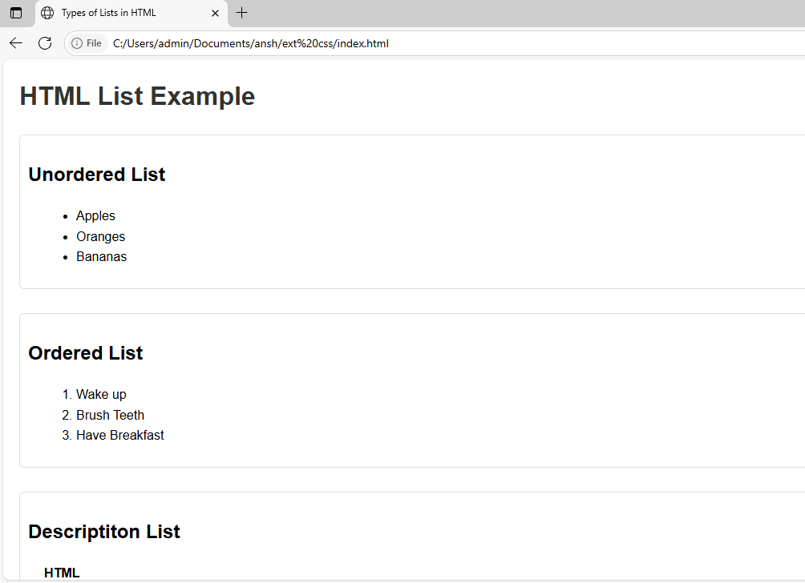

9)BCA table
<!DOCTYPE html>
<html>
<head>
<title>BCA Table</title>
<style>
table {
border - collapse: collapse;
width: 60%;
text-align: center;
}
th,td{
border: 1px solid black;
padding: 8px;
}
.center-text{
text-align:center;
font-weight:bold;
}
</style>
</head>
<body>
<table>
<!--Title row--->
<tr>
<th colspan="5" class="center-text">BCA</th>
</tr>

<!--Header Row-->
<tr>
<td rowspan="2">SEM I &amp;II</td>
<th>Java</th>
<th>CSS</th>
<th>HTML</th>
<th>C</th>
</tr>

<!--Marks Row-->
<tr>
<td>55</td>
<td>63</td>
<td>62</td>
<td>89</td>
</tr>

<!--Footer Row--->
<tr>
<td colspan="5" class="center-text">Thank You</td>
</tr>
</table>
</body>
</html>
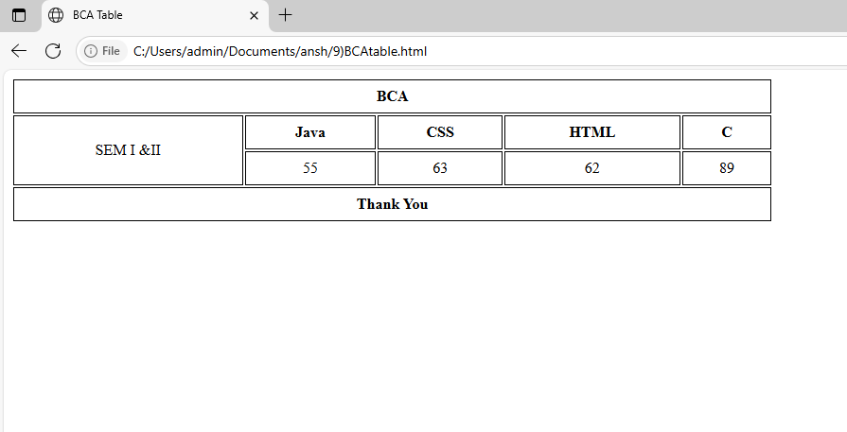
10)Students grade
<!DOCTYPE html>
<html>
<head>
<title>Student Grades</title>
<style>
table{
border-collapse:collapse;
width:50%;
}
th,td{
border:1px solid black;
padding:8px;
text-align:center;
}
tfoot td{
font-weight:bold;
}
</style>
</head>
<body>
<table>
<thead>
<tr>
<th>Name</th>
<th>Sub</th>
<th>Grade</th>
</tr>
</thead>
<tbody>
<tr>
<td rowspan="2">Gautam</td>
<td>Maths1</td>
<td>A</td>
</tr>
<tr>
<td>Maths2</td>
<td>A+</td>
</tr>
<tr>
<td rowspan="2">Sachin</td>
<td>Science1</td>
<td>B+</td>
</tr>
<tr>
<td>Science2</td>
<td>A</td>
</tr>
</tbody>
<tfoot>
<tr>
<td colspan="3">SYBCA</td>
</tr>
</tfoot>
</table>
</body>
</html>
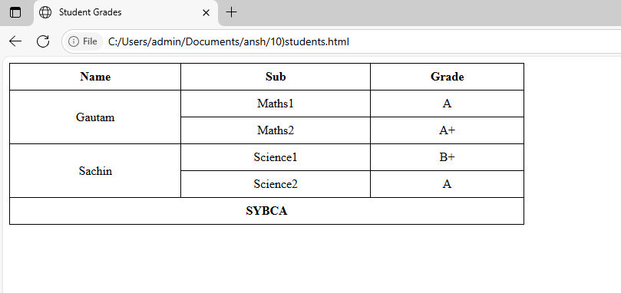

5)Nested table

<!DOCTYPE html>
<html>
<head>
<title>Nested Table Example</title>
<style>
table{
border-collapse: collapse;
margin: 10px;
}
td,th{
border: 2px solid black;
padding : 10px;
text-align: center;
}
.outer {
background-color: #f0f8ff;
}
.inner {
background color: #ffe4e1;
}
</style>
</head>
<body>
<h2> Nested Table Example </h2>

<table class ="outer">
<tr>
<th> Outer Table - Column 1</th>
<th>Outer Table - Column 2</th>
</tr>
<tr>
<td>Row 1, Col 1</td>
<td>
<!--Nested Table Starts Here-->
<table class= "inner">
<tr>
<th>Inner Table - Col 1 </th>
<th>Inner Table - Col 2 </th>
</tr>
<tr>
<td>Nested Row 1</td>
<td>Nested Row 2</td>
</tr>
<tr>
<td colspan="2">Nested Footer </td>
</tr>
</table>
<!--Nested Table Ends Here-->
</td>
</tr>
</table>
</body>
</html>
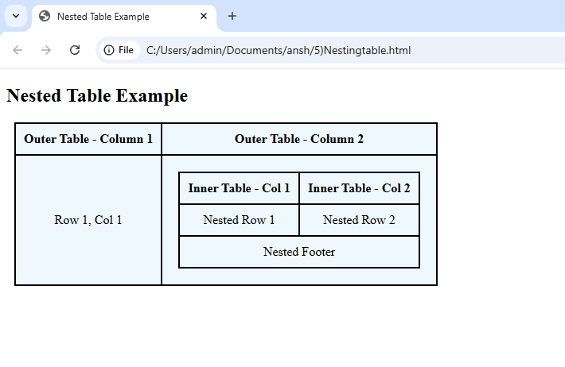

17)College
<!DOCTYPE html>
<html>
<head>
<title>College Information </title>
<style>
.college-name {
font-family: 'Times New Roman', Times, serif;
color: blue;
background-color: yellow;
font -size : 24px;
padding: 10px;
}
.college-info {
color: green;
font-size : 18px;
}
</style>
</head>
<body>

<div class="college-name">
ABC College of Science andTechnology
</div>
<div class="college-info">
ABC College is located in XYZ city and offers undergraduate and postgraduate programs in Science , Technology, Engineering, and Mathematics. The college is affiliated with a reputed university and is known for its excellent faculty and infrastructure.
</div>
</body>
</html>
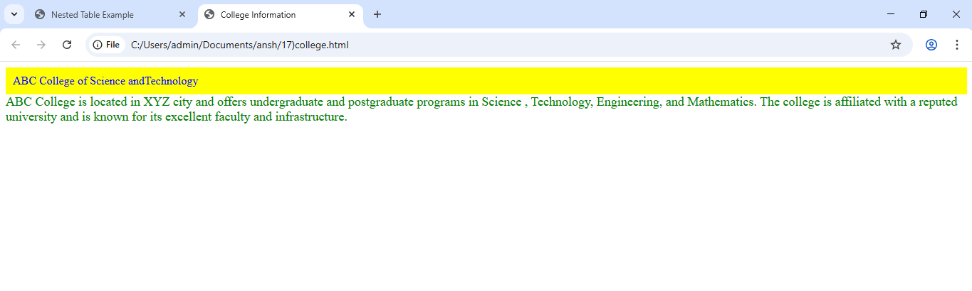
7)Registration
<!DOCTYPE html>
<html>
<head>
<title>User Registration Form</title>
<style>
/* Styling the heading */
h2 {
color: orange; /* Heading color is set to orange */
}

/* Styling the form container */
form {
border: 1px solid #ccc; /* Adds a light gray border */
padding: 20px; /* Adds space inside the form */
width: 300px; /* Sets the form width */
background-color: #f9f9f9;/* Light background color */
}

/* Styling labels and inputs */
label {
display: block; /* Each label on a new line */
margin-top: 10px; /* Adds space above each label */
font-weight: bold; /* Makes labels bold */
}

input {
width: 100%; /* Input takes full width of form */
padding: 8px; /* Padding inside input box */
margin-top: 5px; /* Space between label and input */
box-sizing: border-box; /* Includes padding in width */
}

/* Styling the submit button */
input[type="submit"] {
background-color: #4CAF50;/* Green button */
color: white; /* White text */
border: none; /* No border */
margin-top: 15px; /* Space above button */
cursor: pointer; /* Cursor becomes pointer on hover */
}

input[type="submit"]:hover {
background-color: #45a049;/* Darker green on hover */
}
</style>
</head>
<body>

<h2>User Registration Form</h2>

<form>
<label for="name">Name:</label>
<input type="text" id="name" name="name" required>

<label for="age">Age:</label>
<input type="number" id="age" name="age" required>

<label for="appointment">Date of Appointment:</label>
<input type="date" id="appointment" name="appointment" required>

<input type="submit" value="Submit">
</form>

</body>
</html>
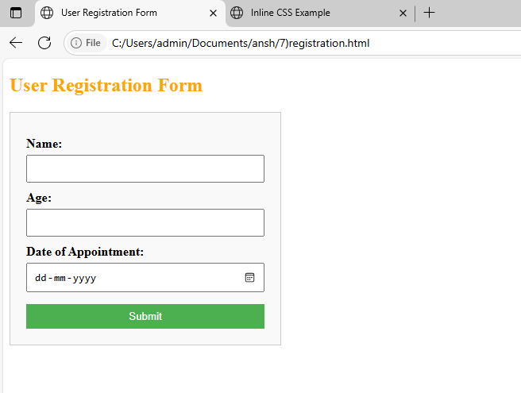

14)Inline css
<!DOCTYPE html>
<html>
<head>
<title>Inline CSS Example</title>
</head>
<body>

<h2 style="color: orange; text-align: center;">Welcome to Inline CSS Demo</h2>

<p style="font-size: 18px; color: blue;">
This paragraph uses inline CSS to make the text blue and increase the font size.
</p>

<div style="background-color: lightgray; padding: 10px;">
<p style="color: green;">This is a paragraph inside a styled div.</p>
<p style="color: red; font-weight: bold;">This is a bold red paragraph.</p>
</div>

<button style="background-color: green; color: white; padding: 8px 16px; border: none;">
Click Me
</button>

</body>
</html>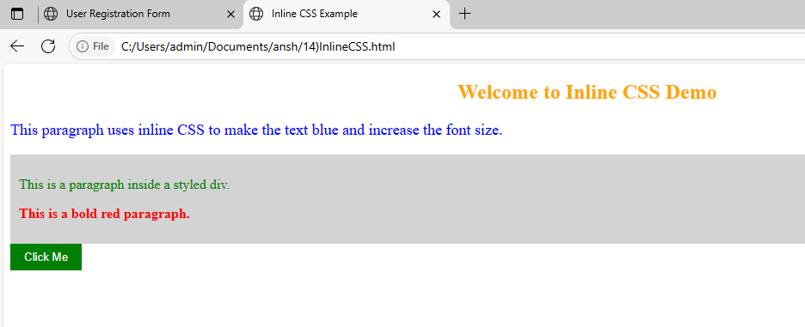
16)All lists
<!DOCTYPE html>
<html>
<head>
<title>All Types of Lists</title>
<style>
body {
font-family: Arial, sans-serif; /* Sets a clean readable font */
margin: 20px; /* Adds space around page */
}

h2 {
color: orange; /* Orange heading color */
}

ul {
list-style-type: square; /* Square bullets for unordered list */
margin-bottom: 20px; /* Space below list */
}

ol {
list-style-type: upper-roman; /* Roman numerals for ordered list */
margin-bottom: 20px;
}

dl {
background-color: #f9f9f9; /* Light background for description list */
padding: 10px;
border-left: 4px solid #ccc; /* Decorative left border */
}

dt {
font-weight: bold; /* Term in description list is bold */
margin-top: 10px;
}

dd {
margin-left: 20px; /* Indent the description */
}
</style>
</head>
<body>

<h2>Unordered List</h2>
<ul>
<li>Apple</li>
<li>Banana</li>
<li>Orange</li>
</ul>

<h2>Ordered List</h2>
<ol>
<li>Wake up</li>
<li>Brush Teeth</li>
<li>Have Breakfast</li>
</ol>

<h2>Description List</h2>
<dl>
<dt>HTML</dt>
<dd>HyperText Markup Language used to structure web pages.</dd>

<dt>CSS</dt>
<dd>Cascading Style Sheets used to style HTML elements.</dd>

<dt>JavaScript</dt>
<dd>A scripting language used to make web pages interactive.</dd>
</dl>

</body>
</html>
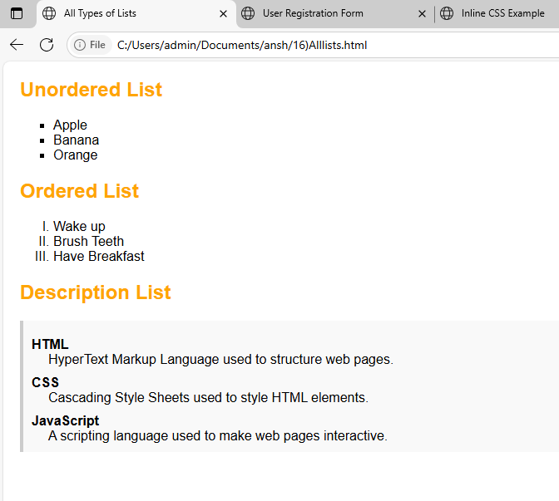
21)html and css
<!DOCTYPE html>
<html>
<head>
<title>Simple CSS Page</title>
<style>
/* Apply Arial font to the whole page */
body {
font-family: Arial, sans-serif;
}

/* Make heading red */
h1 {
color: red;
}

/* Optional: Style ordered list for better spacing */
ol {
margin-top: 10px;
padding-left: 20px;
}

li {
margin-bottom: 5px;
}
</style>
</head>
<body>

<h1>My Favorite Activities</h1>

<ol>
<li>Reading Books</li>
<li>Playing Football</li>
<li>Learning HTML & CSS</li>
<li>Watching Documentaries</li>
</ol>

</body>
</html>
